**Unit – III: Cloud Computing Basics**

**Cloud computing fundamentals**

What is Cloud?

The term Cloud refers to a Network or Internet. In other words, we can say that Cloud is something, which is present at remote location. Cloud can provide services over network, i.e., on public networks or on private networks, i.e., WAN, LAN or VPN. Applications such as e-mail, web conferencing, customer relationship management (CRM),all run in cloud.

What is Cloud Computing?

Cloud Computing refers to manipulating, configuring, and accessing the applications online. It offers online data storage, infrastructure and application.



Basic Concepts

There are certain services and models working behind the scene making the cloud computing feasible and accessible to end users. Following are the working models for cloud computing:

* Deployment Models
* Service Models

**DEPLOYMENT MODELS**

Deployment models define the type of access to the cloud, i.e., how the cloud is located? Cloud can have any of the four types of access: Public, Private, Hybrid and Community.



P U B L I C C L O U D

The Public Cloud allows systems and services to be easily accessible to the general public. Public cloud may be less secure because of its openness, e.g., e-mail.

P R I V A T E C L O U D

The Private Cloud allows systems and services to be accessible within an organization. It offers increased security because of its private nature.

C O M M UN I T Y C L O U D

The Community Cloud allows systems and services to be accessible by group of organizations.

H Y B R I D C L O U D

The Hybrid Cloud is mixture of public and private cloud. However, the critical activities are performed using private cloud while the non-critical activities are performed using public cloud.

**SERVICE MODELS**

**Service Models** are the reference models on which the Cloud Computing is based. These can be categorized into three basic service models as listed below:

1. Infrastructure as a Service (IaaS)

2. Platform as a Service (PaaS)

3. Software as a Service (SaaS)

There are many other service models all of which can take the form like **XaaS**, i.e., **Anything as a Service**. This can be **Network as a Service, Business as a Service, Identity as a Service, Database as a Service** or **Strategy as a Service.** The **Infrastructure as a Service (IaaS)** is the most basic level of service. Each of the service models make use of the underlying service model, i.e., each inherits the security and management mechanism from the underlying model, as shown in the following diagram:



INFRASTRUCTURE AS A SERVICE (IAAS)

**IaaS** provides access to fundamental resources such as physical machines, virtual machines, virtual storage, etc.

PLATFORM AS A SERVICE (PAAS)

**PaaS** provides the runtime environment for applications, development & deployment tools, etc.

SOFTWARE AS A SERVICE (SAAS)

**SaaS** model allows to use software applications as a service to end users.

**MULTITENANCY**

Multitenancy allows multiple users to share single instance of resources in virtual isolation. Consumers can customize their application without affecting the core functionality.

**Cloud Cube Model**

Cloud Computing provides a massive possibility of scalability and has immediate availability at a low cost. There is a popular Model in Cloud Computing, and it is known as The Cloud Cube Model. This popular model was launched by Jericho Forum, and it is mainly used for allowing safe and secure collaboration with suitable cloud formations which are best for the business requirements. Let us learn more about Cloud Cube Model.

**What is the Cloud Cube Model?**

The Cloud Cube models help in classifying the cloud-based network in four essential dimensional elements. The primary aim of this cloud model is to provide security and protect the web or network of the cloud. The cloud model supports selecting cloud creation for the security alliance.

Cloud Cube Model will offer a secure and protected network in companies and business leaders.

Security is a crucial element for the users adopting cloud technology, and almost all the users understand and try to solve their concerns. It is the responsibility of the customer that the selected cloud formation meets the administrative and location requirements.

One more important thing that should be kept in mind is that if the cloud providers stop offering their services, then which options the organizations can rely and move forward with their operations.

Below there are three models that a Cube model consist and they are as follows:

* SaaS
* PaaS
* IaaS

And there are four deployments models also

* Public Cloud
* Private Cloud
* Community Cloud
* Hybrid Cloud

These models are very flexible, user-friendly and it offers countless benefits to cloud users.

**How is Data Safe in the Cloud Cube Model?**

Below we have mentioned multiple considerations that the user has to keep in mind while securing the data in the Cloud Cube Model. They are as follows:

The user must have the information about the data categorization, and they must know what rules and regulations must be applied to keep them safe and secure.

They should make sure that the data is stored at only specific trust volume levels.

The data must be examined with regular regulatory compliance, which is applied.

After the categorizing of data is completed, it can be stored in the required zone and assigned to the users who have the authority to decide the following features:

The data and processes which has to be moved in the cloud

At which level the customer wishes to operate in the cloud. It might be the infrastructure, platform, and software.

The cloud formations must fulfill the necessities

In the cloud operation level can be different depending upon the requirement

**Dimensions of Cloud Cube Model**

Jericho Forum has pointed out multiple cloud service providers, and they claim to provide solutions. Thus, the customers using Cloud Computing require help in choosing the correct data within CCM which is suitable for their requirements. In CCM, there are four various dimensions.

The dimensions are as follows:

1. External and internal

2. Proprietary and Open

3. Perimeterized or known as (Per) and De-Parameterized or (D-p)

4. In Sourced and Outsourced

**Challenges in Cloud Computing**

Cloud Computing, an emergence technology, has placed many challenges in different aspects. Some of these are shown in the following diagram:



**SECURITY & PRIVACY**

Security and Privacy of information is the biggest challenge to cloud computing. Security and privacy issues can be overcome by employing encryption, security hardware and security applications.

**PORTABILITY**

This is another challenge to cloud computing that applications should easily be migrated from one cloud provider to another. There should not be vendor lock-in. However, it is not yet made possible because each of the cloud provider uses different standard languages for their platforms.

**INTEROPERABILITY**

Application on one platform should be able to incorporate services from other platform. It is made possible via web services. But writing such web services is very complex.

**COMPUTING PERFORMANCE**

To deliver data intensive applications on cloud requires high network bandwidth, which results in high cost. If done at low bandwidth, then it does not meet the required computing performance of cloud application.

**RELIABILITY AND AVAILABILITY**

It is necessary for cloud systems to be reliable and robust because most of the businesses are now becoming dependent on services provided by third-party.

**Cloud Computing Framework**

The following diagram shows the framework for mobile cloud computing architecture,



Issues Despite of having significant development in field of mobile computing, there still exists many issues:

**EMERGENCY EFFICIENT TRANSMISSION**

There should be a frequent transmission of information between cloud and the mobile devices.

**ARCHITECTURAL ISSUES**

Mobile cloud computing is required to make architectural neutral because of heterogeneous environment.

**LIVE VM MIGRATION**

It is challenging to migrate an application, which is resource-intensive to cloud and to execute it via Virtual Machine.

**MOBILE COMMUNICATION CONGESTION**

Due to continuous increase demand for mobile cloud services, the workload to enable smooth communication between cloud and mobile devices has been increased.

**SECURITY AND PRIVACY**

This is one of the major issues because mobile users share their personal information over the cloud.

**Amazon EC2**

Amazon Elastic Compute Cloud (Amazon EC2) provides scalable computing capacity in the Amazon Web Services (AWS) Cloud. Using Amazon EC2 eliminates your need to invest in hardware up front, so you can develop and deploy applications faster. You can use Amazon EC2 to launch as many or as few virtual servers as you need, configure security and networking, and manage storage. Amazon EC2 enables you to scale up or down to handle changes in requirements or spikes in popularity, reducing your need to forecast traffic.

Amazon EC2 provides the following features:

* Virtual computing environments, known as instances
* Preconfigured templates for your instances, known as Amazon Machine Images (AMIs), that package the bits you need for your server (including the operating system and additional software)
* Various configurations of CPU, memory, storage, and networking capacity for your instances, known as instance types
* Secure login information for your instances using key pairs (AWS stores the public key, and you store the private key in a secure place)
* Storage volumes for temporary data that's deleted when you stop, hibernate, or terminate your instance, known as instance store volumes
* Persistent storage volumes for your data using Amazon Elastic Block Store (Amazon EBS), known as Amazon EBS volumes
* Multiple physical locations for your resources, such as instances and Amazon EBS volumes, known as Regions and Availability Zones
* A firewall that enables you to specify the protocols, ports, and source IP ranges that can reach your instances using security groups
* Static IPv4 addresses for dynamic cloud computing, known as Elastic IP addresses
* Metadata, known as tags, that you can create and assign to your Amazon EC2 resources
* Virtual networks you can create that are logically isolated from the rest of the AWS Cloud, and that you can optionally connect to your own network, known as virtual private clouds (VPCs)

**S3 STORAGE REVISES**

Amazon Simple Storage Service (Amazon S3) is an object storage service offering industry-leading scalability, data availability, security, and performance. Customers of all sizes and industries can store and protect any amount of data for virtually any use case, such as data lakes, cloud-native applications, and mobile apps. With cost-effective storage classes and easy-to-use management features, you can optimize costs, organize data, and configure fine-tuned access controls to meet specific business, organizational, and compliance requirements.

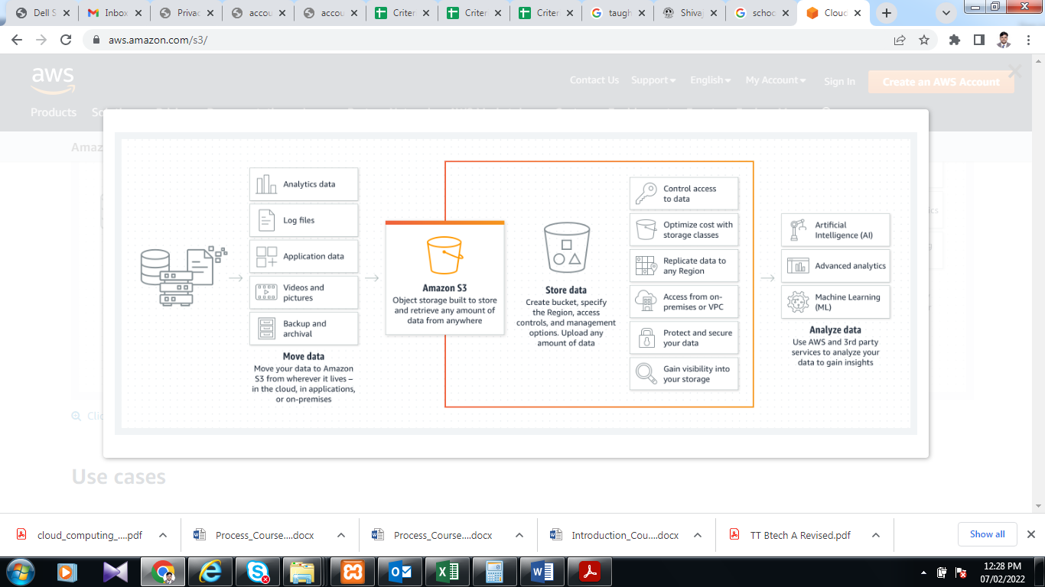

**Aneka Framework**

Aneka includes an extensible set of APIs associated with programming models like MapReduce.

These APIs support different cloud models like a private, public, hybrid Cloud.

Manjrasoft focuses on creating innovative software technologies to simplify the development and deployment of private or public cloud applications. Our product plays the role of an application platform as a service for multiple cloud computing.

* Multiple Structures:
* Aneka is a software platform for developing cloud computing applications.
* In Aneka, cloud applications are executed.
* Aneka is a pure PaaS solution for cloud computing.
* Aneka is a cloud middleware product.
* Manya can be deployed over a network of computers, a multicore server, a data center, a virtual cloud infrastructure, or a combination thereof.

### Multiple containers can be classified into three major categories:

* Textile services
* Foundation Services
* Application Services

**1. Textile Services:**

Fabric Services defines the lowest level of the software stack that represents multiple containers. They provide access to resource-provisioning subsystems and monitoring features implemented in many.

**2. Foundation Services:**

Fabric Services are the core services of Manya Cloud and define the infrastructure management features of the system. Foundation services are concerned with the logical management of a distributed system built on top of the infrastructure and provide ancillary services for delivering applications.

**3. Application Services:**

Application services manage the execution of applications and constitute a layer that varies according to the specific programming model used to develop distributed applications on top of Aneka.